Project Design Phase-II
Data Flow Diagram & User Stories

Date | 25 SEPTEMBER 2026
Team ID | SWTID-2026-4296
Project Name | AI StudyBuddy
Maximum Marks | 4 Marks

Data Flow Diagrams:
A Data Flow Diagram (DFD) is a traditional visual representation of the information flows within a system. A neat and clear DFD can depict the right amount of the system requirement graphically. It shows how data enters and leaves the system, what changes the information, and where data is stored.
Example: DFD Level 0 (AI studybuddy)

Project DFD: (Simplified)
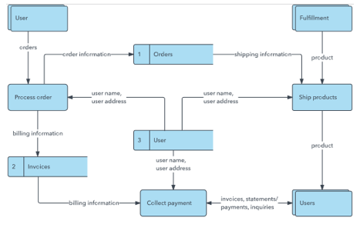
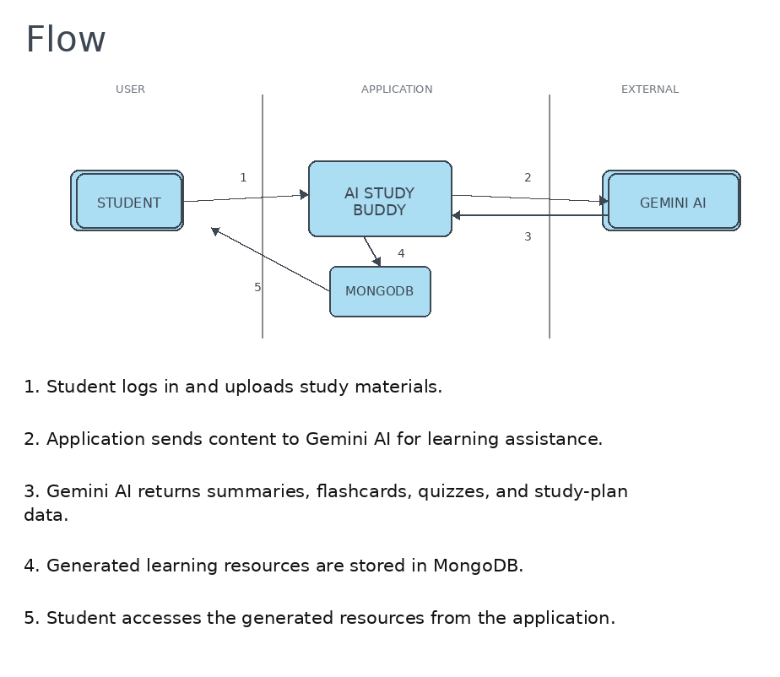

User Stories
Use the below template to list all the user stories for the product.
User Type | Functional Requirement (Epic) | User Story Number | User Story / Task | Acceptance criteria | Priority | Release
Student (Web user) | Registration | USN-1 | As a user, I can register for the application using my email and password. | I can access my account / dashboard | High | Sprint-1
 |  | USN-2 | As a user, I can log into the application using my registered email and password. | I can securely access my dashboard | High | Sprint-1
 | Study Material Management | USN-3 | As a user, I can upload study materials such as PDFs, notes, and textbooks. | I can upload and access my study material | High | Sprint-1
 |  | USN-4 | As a user, I can view and manage my uploaded study materials. | I can view and manage saved materials | High | Sprint-1
 | AI Summarization | USN-5 | As a user, I can generate a concise summary from my study material. | A summary is generated from the selected material | High | Sprint-2
 | Flashcard Generation | USN-6 | As a user, I can generate flashcards from my study material. | Flashcards are generated for revision | High | Sprint-2
 | Quiz Generation | USN-7 | As a user, I can generate quizzes from my study material. | A quiz is generated for self-assessment | High | Sprint-2
 | Study Planning | USN-8 | As a user, I can create a personalized study plan based on my exam schedule and available time. | A study plan is generated and accessible | High | Sprint-3
 | Learning Resource Management | USN-9 | As a user, I can save generated summaries, flashcards, quizzes, and study plans. | Generated resources can be saved and accessed later | Medium | Sprint-3
 |  | USN-10 | As a user, I can access my saved learning resources from one place. | I can view my saved resources from the dashboard | Medium | Sprint-3
 | Dashboard | USN-11 | As a user, I can view my study materials and generated learning resources from the dashboard. | The dashboard displays available resources | Medium | Sprint-3
 |  | USN-12 | As a user, I can securely access only my own study materials and learning resources. | Only authenticated user resources are accessible | High | Sprint-1

